
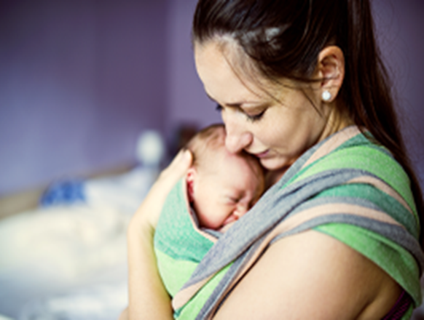
Need support? You are not alone.
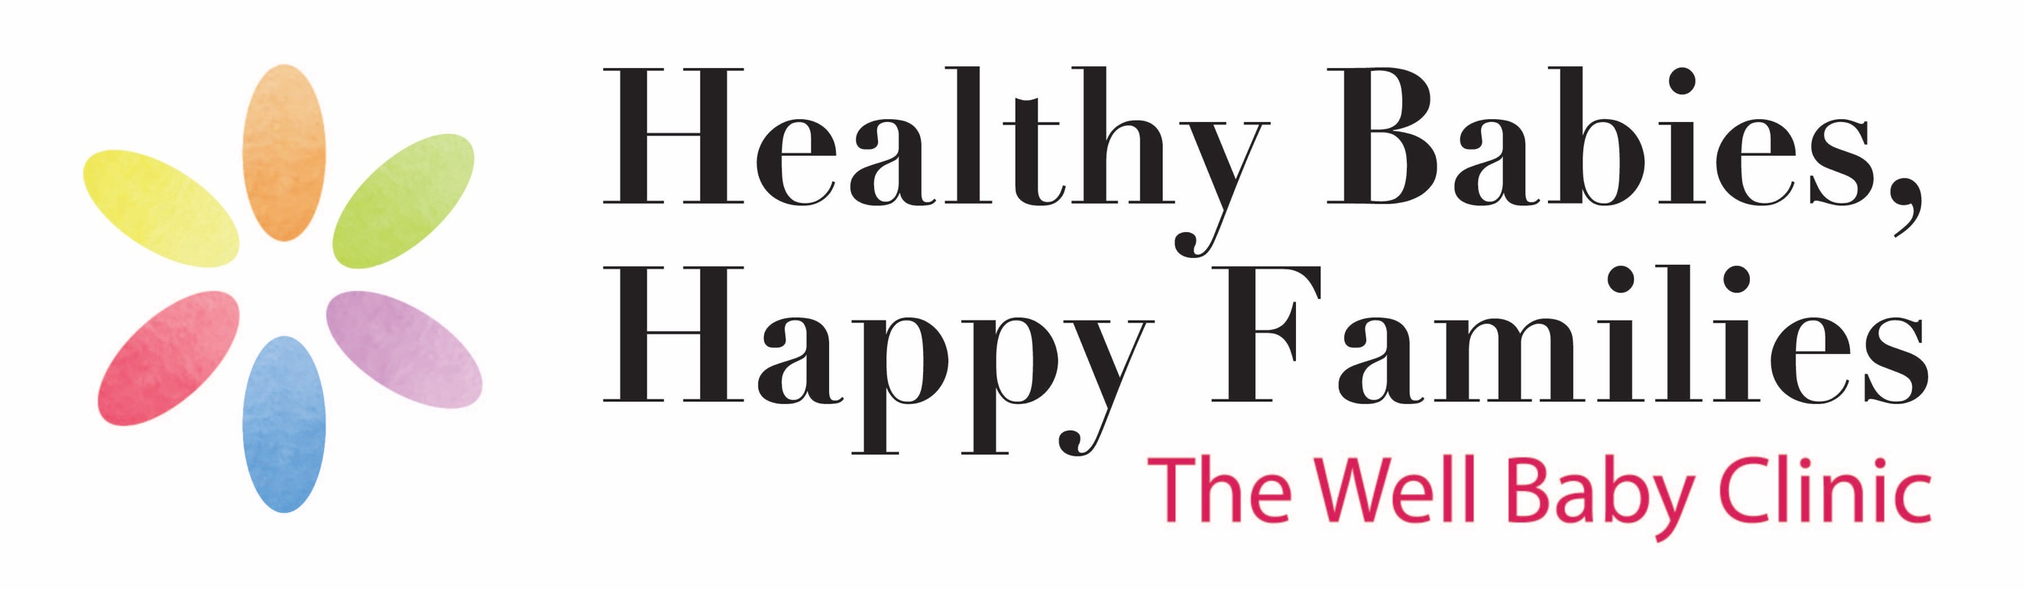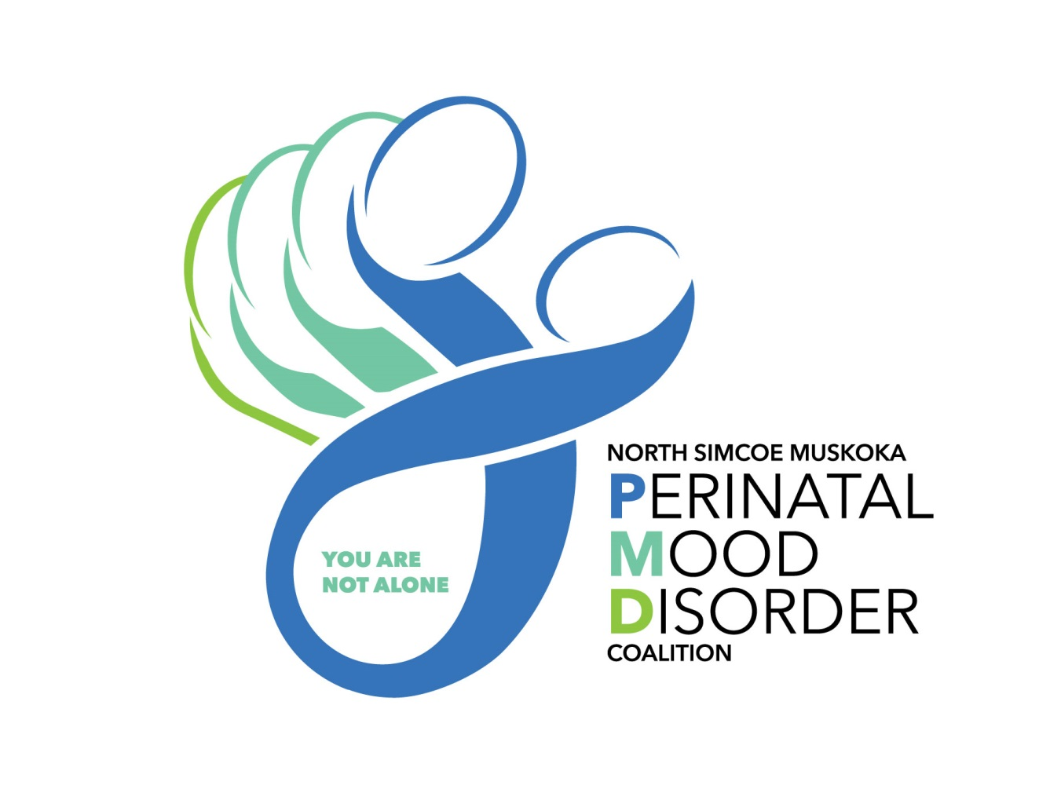
The group will run virtually. For more information or to register please contact Natalie Kirby, Clinic Lead for the HBHF Well-Baby Clinic @ 705-445-4243.

After Baby Group
For parents with mood changes after baby
8 weekly sessions, Tuesdays from 10am– 11:30am
ONLINE SESSIONS starting April 13th, 2021




  - Meet other new parents experiencing
mood changes after birth of baby
  - Discuss relationships, difficult emotions
and how to take care of yourself
  - Build coping skills

