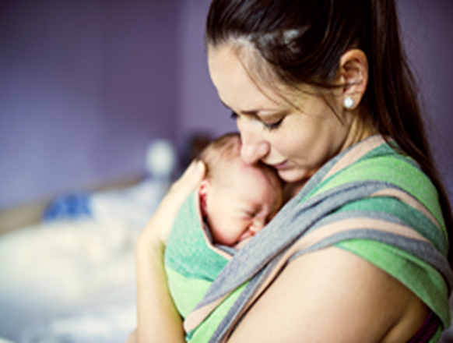

**Need support? You are not alone.**

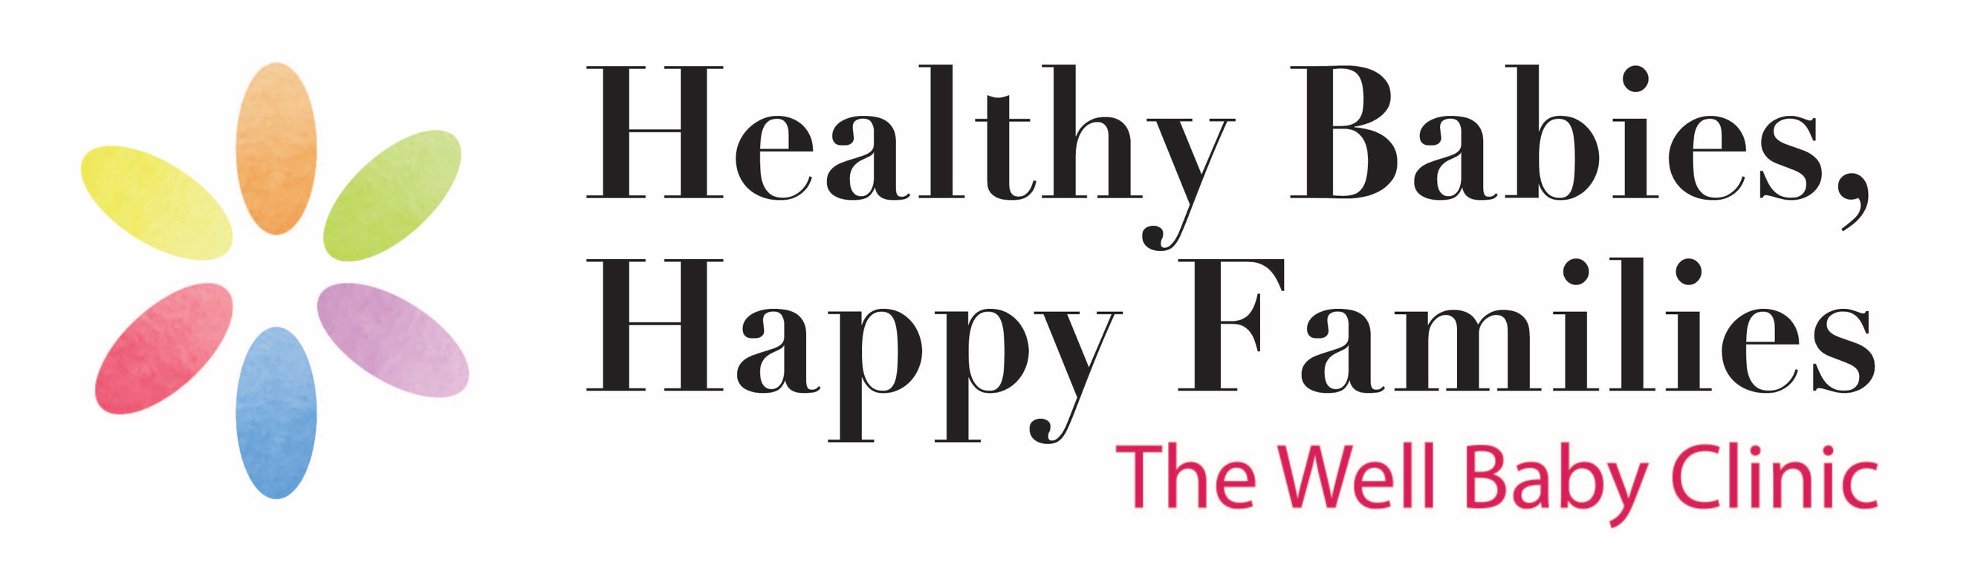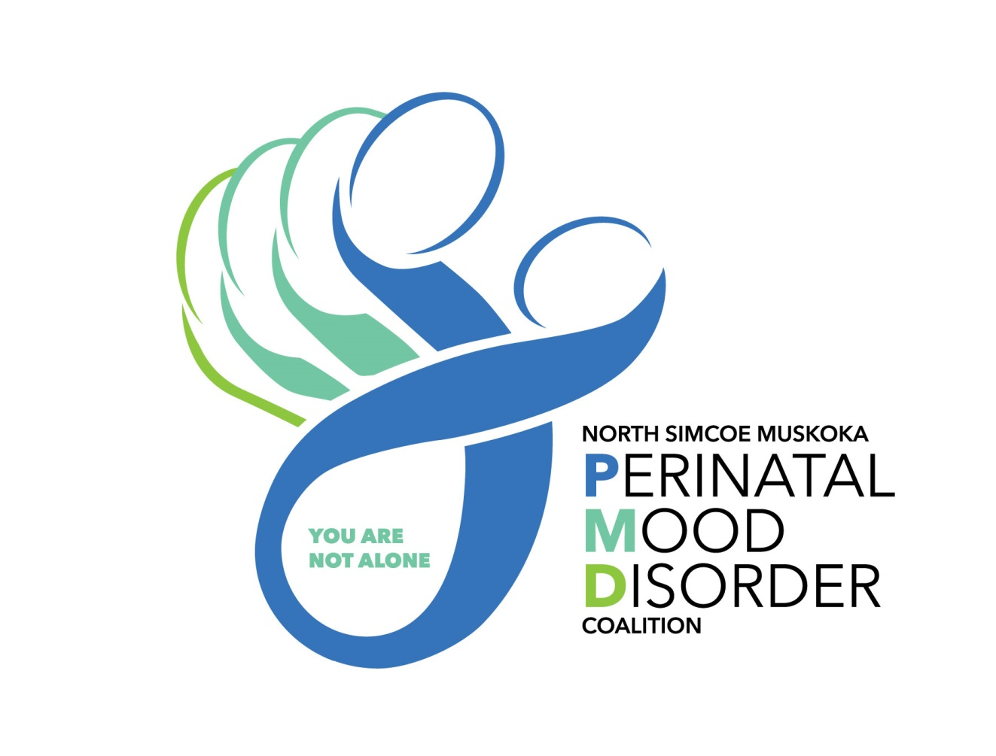

The group will run **virtually**. For more information or to register please contact Natalie Kirby, Clinic Lead for the HBHF Well-Baby Clinic @ 705-445-4243.

**After Baby Group**

For parents with mood changes after baby

8 weekly sessions, Tuesdays from 10am– 11:30am

**ONLINE SESSIONS** starting April 13th, 2021



* + **Meet other new parents experiencing**

**mood changes after birth of baby**

* + **Discuss relationships, difficult emotions**

**and how to take care of yourself**

* + **Build coping skills**